N_QUEEN PROBLEM

NAME: J.L.PUGAZH MUKILAN

REG NO: 22BCE9292 SLOT :L7+L8

1)Solve N queen problem

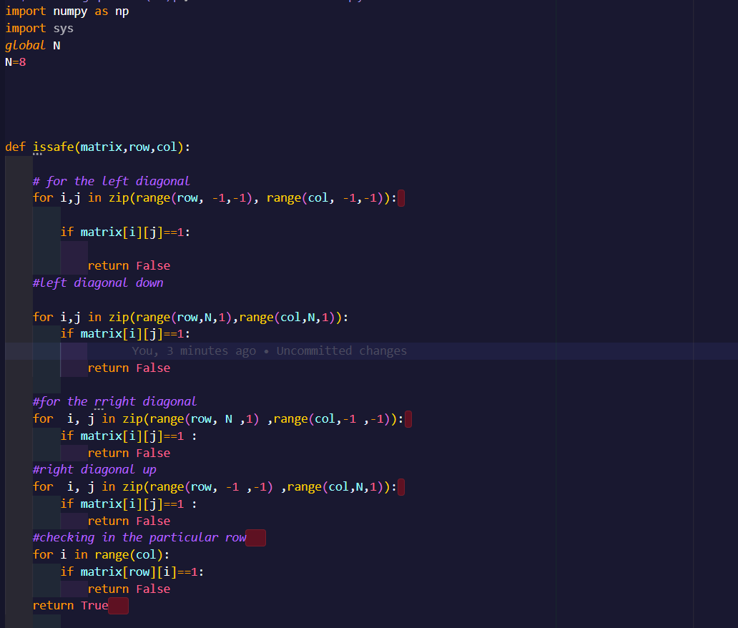

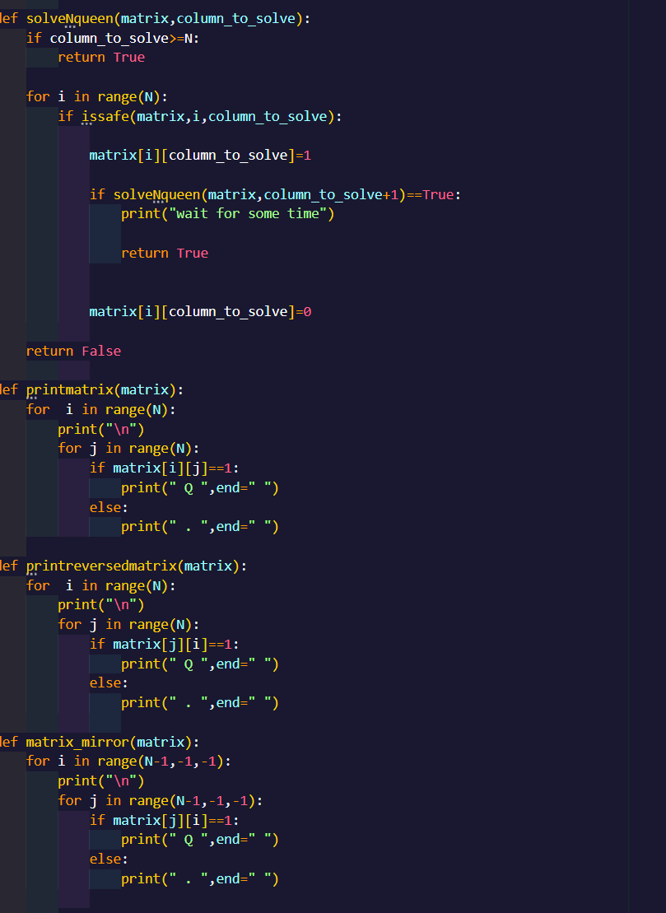­

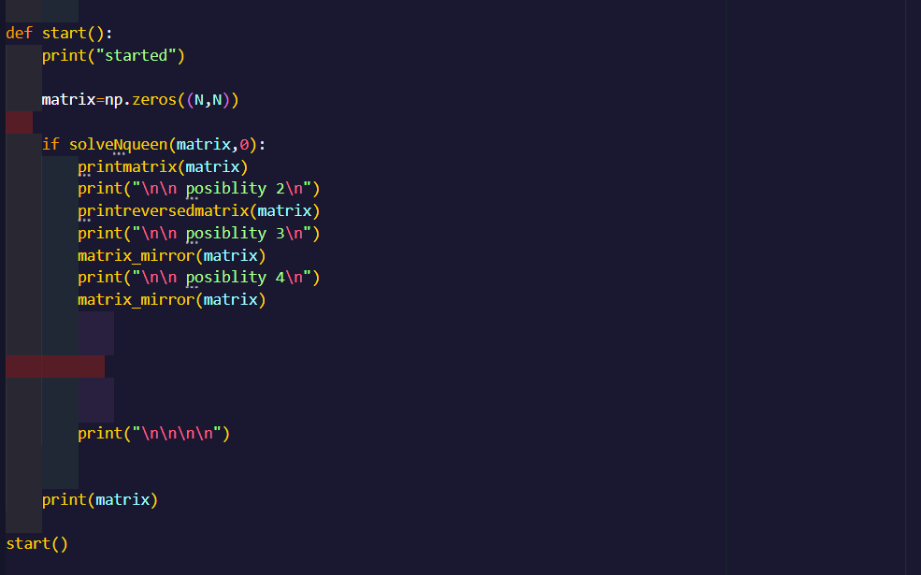

OUTPUT:

8 QUEEN

Possiblity:1 Possiblity:2 Possiblity:3

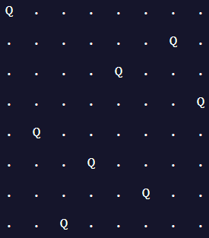 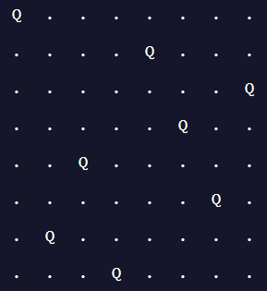 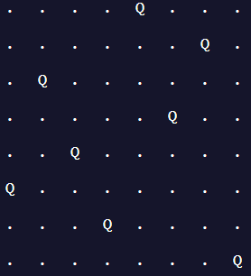

Possiblite:4

